# Numbering rows

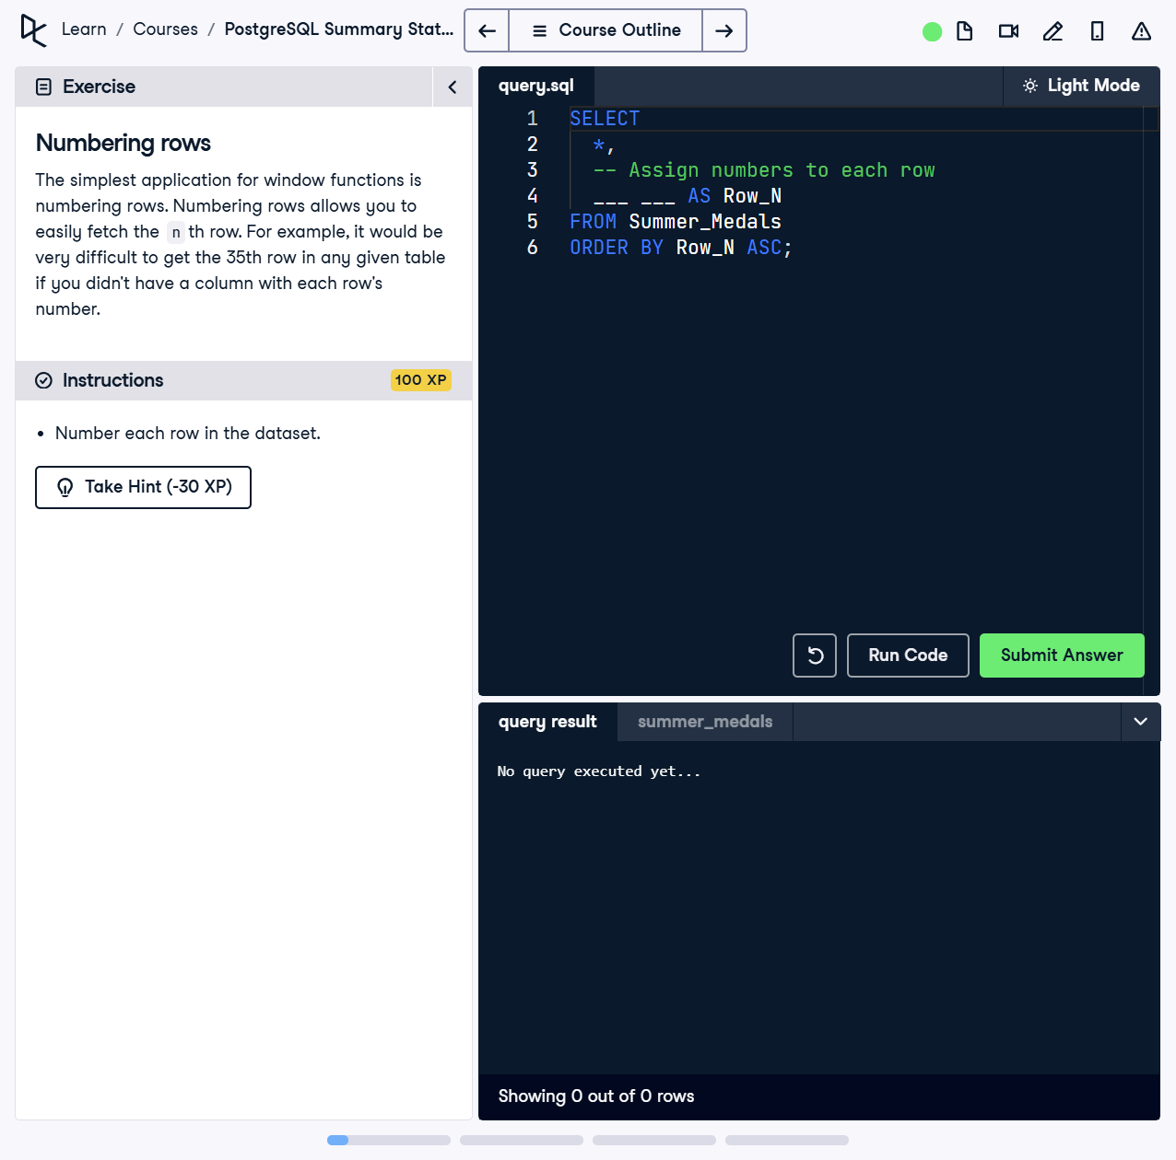

The simplest application for window functions is numbering rows. Numbering rows allows you to easily fetch the nth row. For example, it would be very difficult to get the 35th row in any given table if you didn't have a column with each row's number.

This exercise involves creating a query that assigns a unique number to each row in the dataset. The goal is to number each row and retrieve this as part of the result.

## Answer

SELECT   
 *,   
 ROW_NUMBER() OVER () AS Row_N  
FROM Summer_Medals  
ORDER BY Row_N ASC;

Explanation of the query:

1. `SELECT *, ROW_NUMBER() OVER () AS Row_N`: The `ROW_NUMBER()` function assigns a unique number to each row in the dataset. The `OVER()` clause specifies the window over which the numbering is applied, which in this case includes all rows.

2. `FROM Summer_Medals`: Specifies the table from which rows are selected.

3. `ORDER BY Row_N ASC`: Orders the rows in ascending order of the assigned row number.